Lab 6: Buffers and Bones
Purpose of the Experiment: To understand the nature of a buffer. To prepare a buffer from sodium bicarbonate and sodium carbonate. To test the ability of buffered and unbuffered solutions to resist pH changes when strong acids and bases are added. To investigate the action of acid on biological matter. ¹⁻⁹
Associated text readings: CH9 sections 1,2,3,4,5,6,7,10,11. CH17 section 6.

Background
Part 1:
In a healthy individual, the pH of the blood falls in the range of 7.35-7.45. Even when we eat very acidic substances like oranges, tomatoes, and vinegar, the blood’s pH does not decrease greatly. Similarly, vomiting results in the loss of stomach acid (hydrochloric acid, HCl) but the pH of the blood is maintained at a relatively steady level. How is the body able to maintain the pH of the blood so effectively?

The answer is buffers. A buffer solution is a solution which is able to resist pH changes when small amounts of strong acids or bases are added. Before we discuss buffers, though, let’s review strong acids vs weak acids. As we learned in last week’s lab, strong acids, like HCl, dissociate (ionize) completely. It is a monoprotic acid, meaning it has one proton it can “donate” or ionize. When we write the equation for its dissociation, we write it with an arrow, since it dissociates completely, donating its proton to water, thus forming the H₃O⁺ ion.
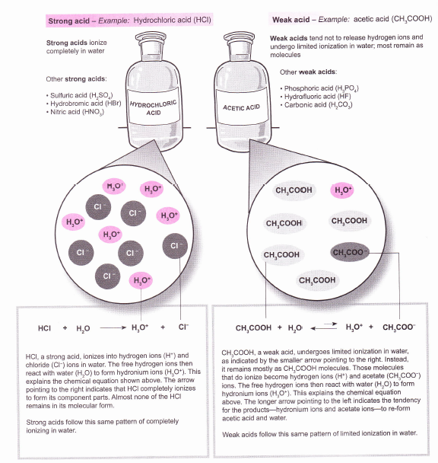

Acetic acid, although it contains 4 protons, only has one ionizable proton, the carboxylic acid proton. It too, is monoprotic. But like other weak acids, acetic acid dissociates to a small extent. So the dissociation/ionization equation is written as an equilibrium expression, since it does not go to completion. We use arrows to signify this.

Buffers resist changes in the pH of solutions when protons (hydrogen ions) or hydroxide ions are added to (or removed) from the solution. A buffer usually is composed of a weak acid and the salt of its conjugate base. We can also prepare a buffer by combining a weak base with the salt of its conjugate acid.

Recall what a conjugate acid base pair is:
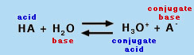

Here, the acid is HA. A⁻ is its conjugate base. It has one less proton and one more negative charge than the original acid. Similarly, when the acid donates its H to water, we get H₃O⁺, which is now capable of donating that proton. It has one more proton and one more (+) charge than the acid we started with, making it a conjugate acid. HA is the acid on the left hand side…and water, being a proton acceptor here, is the Bronstead-Lowry base.

So how do we make a buffer? A buffer can be prepared in two ways.

1. By combining a weak acid and the salt of its conjugate base.
Ex. CH₃COOH and CH₃COONa
H₂CO₃ and NaHCO₃

Here, CH₃COOH and H₂CO₃ are the weak acids. Their conjugate bases are CH₃COO⁻ and HCO₃⁻.

We can also make a buffer:

2. By combining a weak base and its salt.
Ex. NH₃ and NH₄Cl

Here, NH₃ is the weak base. It has a lone pair of electrons on the N, so it is a proton acceptor. Its conjugate acid is NH₄⁺. In the equation above, we show it as a chloride salt.

A weak acid dissociates only slightly in water. Acetic acid, CH₃COOH, loses a proton to form its conjugate base, CH₃COO⁻ , the acetate ion. The acetate is a proton acceptor, and so it is a Bronsted base.

Similarly, sodium bicarbonate, NaHCO₃, can lose a proton, forming the carbonate ion, CO₃²⁻ . Carbonic acid, H₂ CO₃ , is a diprotic acid. But when it donates one proton, it forms the bicarbonate ion, HCO₃⁻, which is a weak acid itself too. The protons are lost one at a time. Sodium bicarbonate is the acid, and the carbonate ion is its conjugate base. It should be noted that we can represent the proton in water (aqueous) solution as H⁺, but it actually combines with water to form the hydronium ion, H₃O⁺.

Please note, the soluble salt of a weak acid is a strong electrolyte and dissociates completely.

H₂O
- CH₃COONa _{(s)} Na⁺_{(aq)} + CH₃COO⁻_{(aq)} (note: Na⁺_{(aq)} means Na⁺ dissolved in H₂O_{(l)} ).

The key to the chemistry behind buffering action is that the solution contains a relatively high concentration of acetic acid molecules and acetate ions. We refer to this as the buffer capacity. High concentrations of both give us a buffer with a high buffer capacity. Low concentrations of both give us a buffer with a low buffer capacity.

We can illustrate the buffering action as follows: When a strong acid (like HCl) is added to the acetic acid/sodium acetate buffer, it donates its proton to water, forming H₃O⁺, which then reacts with the acetate ions to produce acetic acid and water.

(2) H₃O⁺_{(aq)} + CH₃COO⁻_{(aq)} CH₃COOH _{(aq)} + H₂O_{(l)}

Note that this equilibrium lies far to the right. So when a strong acid is added, the conjugate base of the weak acid consumes most of the hydronium ions, and the pH changes very little. When you have a weak acid and a strong acid in the same solution, the strong acid will donate its proton, and the conjugate base of the weak acid accepts it. Both acids cannot be donating. The strong acid “wins”.

If base is added to the buffer, it reacts with the acetic acid molecules to produce acetate ions and water.

(3) OH⁻_{(aq)} + CH₃COOH _{(aq)} H₂O_{(l)} + CH₃COO⁻_{(aq)}

Again, the reaction lies far to the right, and most of the hydroxide ions are consumed, this time, by the weak acid itself. Hydroxide is a strong base. As such, it will accept protons better than the acetate ion. If two bases are present in solution, the strongest base will “win out” and accept the proton. Again, the pH remains relatively constant, and we refer to the solution as being buffered.

Why is a buffer able to absorb acid or base with very little pH change? Let's return again to our acetic acid/sodium acetate system. Let’s assume that our buffer contains equal concentrations of acetic acid (CH₃COOH), and the sodium salt of its conjugate base, sodium acetate (CH₃COONa). CH₃COOH is a weak acid, so when it dissolves in water, only a small fraction dissociates to form its conjugate base CH₃COO⁻. In the buffer solution, however, the sodium acetate provides an equal amount of the conjugate base.
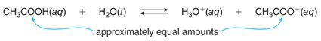
As we saw in CH 9.4, we can write an expression for the acid dissociation constant K_{a} for this reaction as shown below.
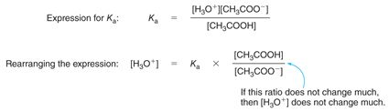
Rearranging this expression to solve for [H₃O⁺] allows us to see why a buffer does not change pH much when acid or base is added. First, remember, pH = -log[H₃O⁺]. The H₃O⁺ concentration depends on two terms—K_{a}, which is a constant, and the ratio of the concentrations of the weak acid and its conjugate base.
The ability of a buffer to minimize changes in H₃O⁺ concentration is called the buffer capacity. The buffer capacity actually depends on two factors—first-- the concentration of the buffer. The more concentrated the buffer, (i.e. the more weak acid and conjugate base we have present) the more reactants we have available to neutralize the added H⁺ and OH⁻ ions. Suppose a small amount of strong acid is added to the buffer. Added H₃O⁺ reacts with CH₃COO⁻to form CH₃COOH, so that [CH₃COO⁻] decreases slightly and [CH₃COOH] increases slightly. However, the ratio of these two concentrations is not altered significantly, so the [H₃O⁺] and therefore the pH change only slightly.
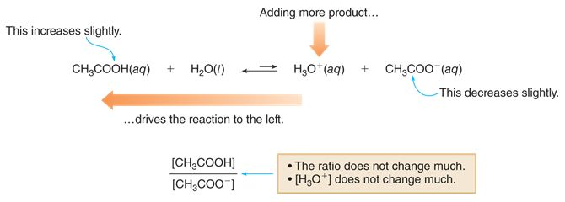

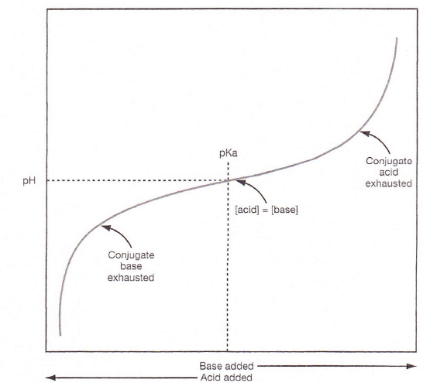
The second factor relates to what we are adding, and how much we are adding. If excessive amounts of either acid or base are added, they can overwhelm the buffering capacity of the solution, and the pH will change considerably. For a buffer to be effective, the amount of added acid or base must be small compared to the amount of buffer present.
When a large amount of acid or base is added to a buffer, the concentrations of the weak acid and its conjugate base change a great deal, so the H₃O⁺concentration changes a great deal as well.
Looking at the graph to the right, we can see to the left, that when sufficient acid is added to the buffer system, the conjugate base is “used up”. To the far right of the graph, we see that when large amounts of base are added to the system, the weak acid is “used up”. When this happens, we have swamped the buffer capacity of our solution.
Revisiting our earlier equation:

Let’s say the concentration of weak acid and weak base are equal, the equation above becomes [H₃O⁺] = K_{a} X 1
Taking the log of both sides, we get pH = pKa. (pKa is the log of the acid dissociation constant, Ka). When pH = pKa, this is significant, because in general, maximum buffering capacity is found at that point. The effective range at which a buffer works best really depends on the Ka of the acid, and the relative concentrations of acid and base. Good buffers usually have high concentrations of weak acid and conjugate base compared to the amount of strong(er) acid or base that are expected to disturb the buffer system. If the concentration of the weak acid and weak base do not change much, then the concentration of H₃O⁺ and therefore the pH do not change much. One would expect then, that a buffer prepared from equal amounts of weak acid and its conjugate base would minimize pH changes quite effectively. You will test that in today’s lab.
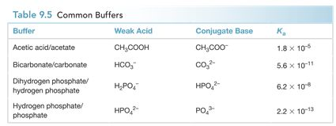
Values for several common buffer systems are given in Table 9.5 from your text below.

The main buffer in the bloodstream is the carbonic acid-bicarbonate buffer. This system keeps blood pH in the range of 7.35-7.45. The pH of the blood is maintained by two independent physiological systems. Carbonic acid (H₂CO₃) concentration can be controlled by respiration through the lungs, and bicarbonate concentration can be controlled by the kidneys, with excess bicarbonate ions (HCO₃⁻) being excreted in the urine. These two systems are coupled together by the two equilibria shown below.

When your body undergoes metabolic reactions, H⁺ is formed (e.g. from lactic acid, via strenuous exercise). We see that the H⁺ reacts with HCO₃⁻ to form the weak acid H₂CO₃.
H⁺_{(aq)} + HCO₃⁻ _{(aq)} H₂CO_{3(aq)}

However, carbonic acid is not a stable acid, and it rapidly forms CO₂ and H₂O.

H₂CO_{3(aq)} H₂O_{(l)} + CO_{2(g)}

In the body, excess CO₂ greatly stimulates breathing, which eliminates the CO₂ from the extracellular fluid via the lungs.
When small amounts of acids or bases enter the bloodstream, the carbonic acid buffer reacts with them to minimize the change in blood pH, as shown below:
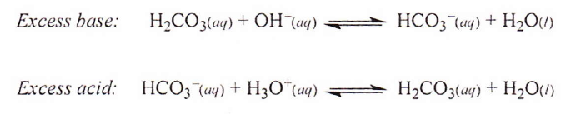

Excess base reacts with the carbonic acid (H₂CO₃) in the buffer, and excess acid reacts with the bicarbonate (HCO₃⁻) in the buffer. After this occurs, we again have only the carbonic acid, bicarbonate, and water that were present in the original buffer solution: the excess acid or base has been “removed”, keeping the pH nearly unchanged.
In today’s experiment, you will prepare buffer solutions of sodium bicarbonate and sodium carbonate. You will test the buffering capacity of this system by adding hydrochloric acid and sodium hydroxide separately to it and observing the buffering action, i.e. the resistance to pH changes. You will also test distilled water and single components of the buffers in the absence of their conjugates to see how they hold up to the challenge of added acid and base.
Part 2:
Bone is a connective tissue. Bones need to be strong and flexible to do their job. If they are strong, but not flexible, they will be easily broken. They are brittle. However, if they are flexible but not strong, they cannot support the weight of your body. Bone is made up of organic proteins (mainly collagen) and hydroxyapatite, an inorganic mineral. Together they provide a mechanical and supportive role in the body.
Approximately 30% of bone is comprised of organic compounds of which nearly 90-95% is collagen. Collagen, as we will see in chapter 21, is a fibrous protein. It gives the bone flexibility. It is also an important component of other tissues, such as tendons. It is a stringy rubbery polymer…the end of your nose is made up of it. Babies have their bones made entirely of collagen. It is flexible and tough, but not rigid. The hydroxyapatite is brittle and hard, giving your bones their strength.
Seventy percent of bone is made up of hydroxyapatite, an inorganic mineral that includes calcium carbonate, calcium phosphate, calcium fluoride, calcium hydroxide and citrate. These minerals make the bone hard and rigid. The collagen gives the bone flexibility.

In today’s lab, you will study what happens when bones lose their strength. You will study the effect of acid on chicken bones and tendons. Hydroxyapatite is soluble in acid. What remains should be in large part the collagen that remains.

PROCEDURES:

Part 1: The Preparation and study of the Carbonate Buffer System:

- Obtain approximately 175 mL of 0.20 M sodium bicarbonate solution (A=acid) and 175mL of 0.20 M sodium carbonate solution (B=base), and put each into a 250mL beaker.

- Label ten 60mL Nalgene bottles 1-10. To avoid errors, write the amount of A and B to be added to each bottle on the label as well. On #1, also label 40A, 0B. #2: 30A 10B. #3: 0A 40 B. #4: 10A, 30B. #5: 20A 20B, #6: 40A, 0B, #7: 30A, 10B. #8: 0A, 40B. #9: 10A, 30B, #10: 20A, 20B. Use a graduated cylinder to transfer 30.0 mL of the 0.20M sodium bicarbonate (A) solution into bottles 2 and 7, and 40.0mL into 1 and 6. Measure 10.0 mL into bottles 4 and 9 and 20.0 mL into 5 and 10.

- Use a graduated cylinder to transfer 10.0 mL of the 0.20M sodium carbonate solution (B) solution into bottles 2 and 7, 20.0 mL into bottles 5 and 10, and 30.0 mL into bottles 4 and 9, and 40.0mL into 3 and 8. Cap each and mix well.

- Take another two Nalgene bottles and add 40mL of distilled water (DI) to each of them, and labeling them DI 1 and DI 2.

The Determination of Bicarbonate Buffering Action Toward Acid and Base:

To test the buffering abilities of the solutions, 0.1 M HCl and 0.1 M NaOH will be added to each of your solutions.

  - Obtain a LabQuest with pH probe. Calibrate your pH meter as described in part 3, then rinse the probe with distilled water.

  - Insert the pH probe into bottle #1. Wait about 30 sec, and measure the pH. Then add 5 drops of 0.1 M HCl solution. Carefully swirl the solution, and record the new pH, after waiting about 30 seconds. Add another 5 drops of HCl, wait, and record the new pH. Repeat twice more until you’ve added a total of 20 drop of HCl solution. Record each pH on your Data Sheet. Add 1 mL (20 drops) HCl, swirl, wait, and record the pH of the solution one last time.

  - Rinse the electrode with distilled water and gently blot dry. Repeat step 2 with solutions 2-5.

  - Very thoroughly rinse the electrode with distilled water and gently blot dry. Insert the pH probe into bottle DI #1 (deionized water, #1).

  - Repeat step 2 with DI#1.

  - Rinse the electrode with distilled water and gently blot dry. Insert the pH probe into bottle #6. Wait 30 sec, and then measure the pH. Then add 5 drops of 0.1 M NaOH solution. Carefully swirl the solution, wait and record the new pH. Add another 5 drops of NaOH, wait, and record the new pH. Repeat twice more until you’ve added a total of 20 drops of NaOH solution. Record each pH on your Data Sheet. Add 1 mL (20 drops) NaOH, swirl, wait, and record the pH of the solution one last time.

  - Again rinse the electrode with distilled water and gently blot dry. Repeat step 6 with solutions 7-10.

  - Rinse the electrode thoroughly with distilled water and gently blot dry. Insert the pH probe into bottle DI #2 (deionized water, #2).

  - Repeat step 6 with DI#2.

  - Mix all of your waste and leftover solutions together. Add a small amount of sodium bicarbonate to your waste. You can rinse it down the drain with running water when its pH is between 5-9.

  - Rinse your probe once more and put it in its storage container.

  - Continue to Part 2: Digestion of Animal Materials

Part 2: Digestion of Animal Materials
- Remove your chicken bone(s) from the acid. Pat dry. Obtain its mass using a balance and record it in your DAS.
- Examine the bone. How does it look? Bend it, twist it. Record your observations in your DAS.
- Using your pH probe, obtain the final pH of the digestion jar.
- Remove the chicken tendons/cartilage from the acid. Pat dry. Obtain its mass using a balance and record it in your DAS.
- Examine the material. How does it look? Bend it, twist it. Record your observations in your DAS.
- Using your pH probe, obtain the final pH of the digestion jar.
- Now, examine the contents of your “shell” jar. Is there anything left? If so, remove it from the acid and pat dry. Obtain its mass using a balance and record it in your DAS.
- Examine any remaining material. Record your observations in your DAS. Using your pH probe, obtain the final pH of the digestion jar.
- At the end of lab, mix all of your waste and leftover solutions together. Then add a small amount (~ one tablespoon) of sodium bicarbonate (baking soda) to your waste. You can dump it down the drain with running water when its pH is between 5 and 9.
- Rinse and store the probe.
- Clean glassware and bench, and return the equipment you checked out.

Checkout:
pH probe, Vernier Labquest
60ml Nalgene bottles with caps (12)
600ml waste beaker
250ml beakers (2)
10ml, 50mL graduated cylinders
Wash bottle
Utility clamp

Citations

1. Kelter, P.; Carr, J.; Scott, A. Laboratory Manual to Accompany Chemistry A World of Choices; McGraw Hill: Boston, 1999.
2. http://chemistry.olivet.edu/classes/chem100/pdf/Labs/Buffers%20Lab.PDF, (accessed 7-9-13).
3. Zumdahl, S.S., Chemistry, 4th ed.; Houghton Mifflin: Boston, 2000.
4. Smith, J., General, Organic, and Biological Chemistry, 2nd ed.; McGraw Hill: NY, 2012.
5. Krieger, P.A. A Visual Analogy Guide to Chemistry; Morton: Englewood (CO), 2012.
6. The DASH Project, Activity 5.3.16 Chemistry and Bones; University of Hawaii, DRDG, pp. 5.2.16-1-4.
7. Applegate, C.; Neely, M.B. Sakuta, M. Laboratory Manual for General, Organic & Biological Chemistry; McGraw-Hill: New York; 2016: pp. 233-240.
8. Henrickson, C.H.; Byrd,L.C.; Hunter, N.W. A Laboratory Manual for General, Organic, and Biochemistry; McGraw-Hill; New York; 2011: pp. 229-243.
9. Anthony, S.; Braun, K.L.; Mernitz, H. ChemConnections Activity Workbook; Norton: New York; 2013: pp. 253-260.

Part 3: Operation of the pH meter:

In this experiment, you will be using a pH electrode connected to the LabQuest. The probe is fragile and costly to replace. Be careful not to push the electrode into the bottom of your glassware or to drop it. There is a protective guard around the tip. The guard will not protect against careless treatment.
Best results will be obtained if:
- Electrodes are kept wet when not in use.
- Immediately prior to use, the electrode is rinsed with deionized water (DI) and gently blotted with a KimWipe, then placed in the test solution.
- The electrode is rinsed and blotted again between measurements.
- When done, the probe should be rinsed again and returned to the KCl solution vial for storage.
- To ensure the safety of the probe, use a utility clamp to attach it to your monkey bars, and suspend it over the solution whose pH you are measuring. Move the solution to the meter, (not vice versa).



