**Lab 12: DNA or Protein?**

**Purpose of the Experiment:To become familiar with the physical properties of DNA by isolating it from living tissue; to compare and contrast the differences between protein and DNA.**

**Associated text readings: CH21, sections 6,8,9. CH22, sections 1,2,3,4,5,6,7,8.**

**Background**

Proteins and DNA differ from each other in major ways. As we have studied already, proteins are chains of amino acids strung together like beads in a necklace. The proteins exhibit different types of structures. **1.** The primary structure is the order of the amino acids, which forms the backbone of the protein. This is shown below. This is not unlike the sequence of colored pearls in the strand of the multicolored pearl necklace as shown on the right.

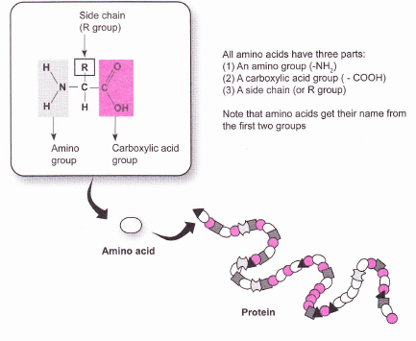

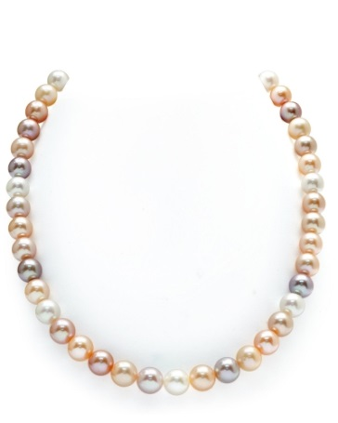

**2.** Proteins also exhibit secondary structures, which are localized regions with particular shapes, such as an alpha helix or a beta pleated sheet. Both are shown below. Similarly, the pearl necklace at the right exhibits localized “looped” regions of secondary structure.

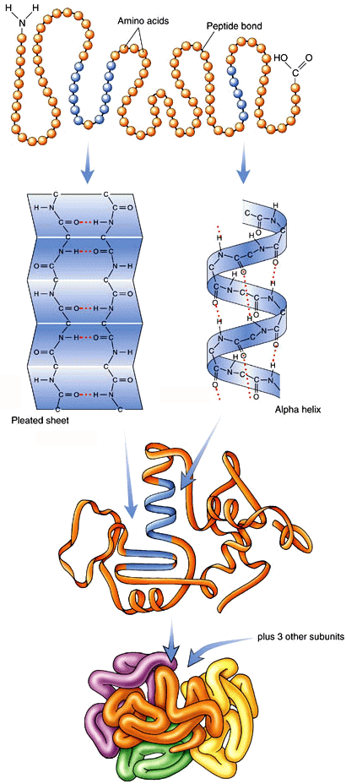

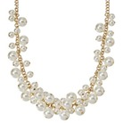**3.** The overall 3-D shape of the protein is the tertiary shape. This contains secondary structures, but here, we are talking about the overall shape of the chain that makes up the protein. Again, a pearl necklace exhibits a 3D shape as well.

**4.** Proteins with more than one chain exhibit NOT ONLY 1o, 2o, and 3o structure, they also exhibit quaternary, 4o, structure. This is the overall 3D shape that the aggregate of the multiple chains exhibits. Hemoglobin is the classic example, and is shown at left. It contains 4 chains. Myoglobin, with only 1 chain, only displays 1o, 2o, and 3o structure. Again, a pearl necklace, this time with multiple chains, exhibits 1o, 2o, 3o and 4o structure. This necklace also displays cross linking between the chains (see the white pearl beads linking the upper left and right portions of the necklace…this would be like a disulfide bond stabilizing protein structure.





In all cases of the proteins, their structures are integrally related to their function. If the structure is lost, the protein is denatured, and loses its ability to function. This would happen when you cook an egg. Egg white proteins are globular. The long amino acid chain is twisted and curled into a roughly spherical shape, with the hydrophobic amino acids tucked into the interior of the protein. The hydrophilic amino acids are attracted to water, allowing the protein (most of the protein of an egg white is the protein albumin) to be water soluble. However, heat applied to the protein agitates the molecules, causing them to collide with one another and break the intermolecular forces that maintain the protein’s native (natural) structure. The protein molecules uncurl, and form bonds with neighboring protein molecules. Instead of single individual protein molecules floating in solution, one now has a network of interconnected proteins that form a rubbery white insoluble mass. These structural disruptions keep the protein from performing its natural function.

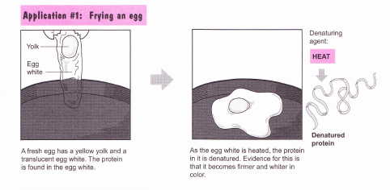

Similar processes occur when acid or ethanol is added to a protein. Its 3D structure is disrupted. Nevertheless, the fact remains: proteins, whether intact, or denatured, are composed of chains of amino acids.

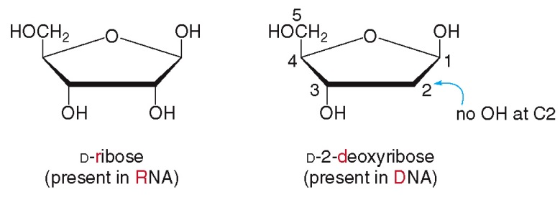**Nucleic acids** are polymers of nucleotides. A nucleotide consists of a phosphate group, a ribose or deoxyribose sugar, and a nitrogenous base. DNA, **deoxyribonucleic acid**, is composed of the sugar deoxyribose and a nitrogenous base, whereas RNA, **ribonucleic acid**, is composed of the sugar ribose, plus nitrogenous bases.

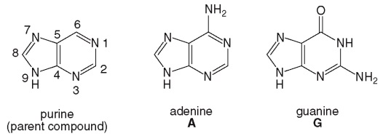

Both DNA and RNA have adenine and guanine (shown at right).

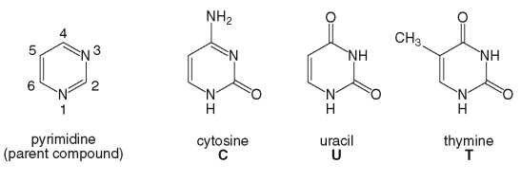However, only DNA has thymine, while only RNA has uracil (shown at right).

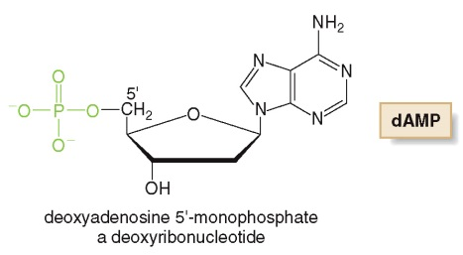A nucleotide made from adenine and deoxyribose is shown below. It is abbreviated dAMP because it has deoxyribose (ergo the “d”), adenine, and 1 phosphate. Note: the linkage between the phosphate and the sugar is an ester linkage, because the phosphate is derived from phosphoric acid. The sugar is numbered starting at 1’ (numbers without primes are reserved for the nitrogenous bases, here, adenine). We begin numbering at the carbon to the right of the oxygen that is contained in the sugar ring. The base connects at carbon 1’, and the phosphate connects at 5’.

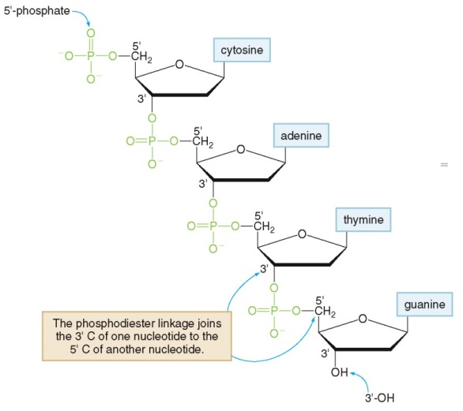

Nucleotides can connect together to form long chains as shown to the right. This polynucleotide would be part of a DNA chain, as the sugar has no oxygen at the 2’ position: it is deoxyribose. Since each phosphate is “sandwiched” between two sugars, it takes part in 2 ester bonds, so we say the chain is connected via phosphodiester bonds.

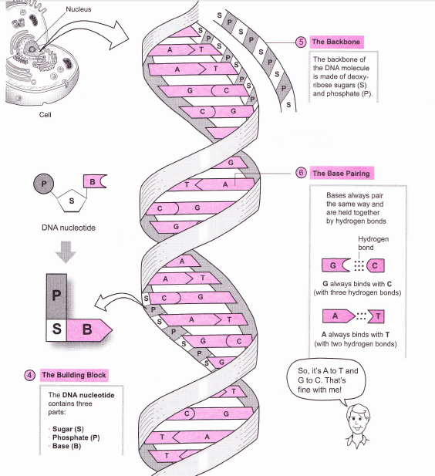

DNA forms double strands of these nucleotides with each nucleotide being joined by a phosphodiester bridge. This forms, then, a backbone composed of phosphate and ribose. This can be pictured as the rails of a ladder.

The nitrogenous bases participate in this double helix and are oriented towards the center of the double helix in order to hydrogen bond to the neighboring strand, not unlike the “rungs” of a ladder. **Adenines** hydrogen bond with **thymines,** and **cytosines** hydrogen bond with **guanines**.

**Ribonucleic acids** (RNA) consist of polymers of nucleotides as well, but with a few differences. RNA’s are single-stranded and contain the base **uracil** in place of thymine. The sugar in RNA also has a 2’ hydroxyl group which is missing in DNA.

The main function of DNA is genetic inheritance and expression of genetic information within the cell. RNA has many varied roles, because there are 3 forms of RNA.

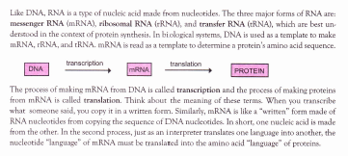

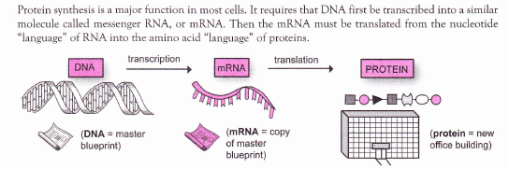

So DNA and RNA are needed in order for the proteins necessary for life to be synthesized. However, DNA and RNA are composed of chains of nucleotides, whereas proteins are chains of amino acids.

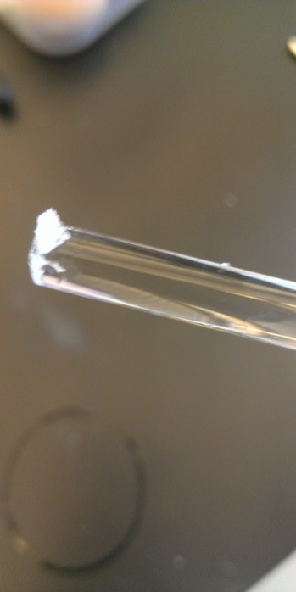In this lab, you will isolate genomic DNA from onion cells. The cells will be lysed (break down of the cell walls, plasma membranes and the nuclear material) using a homogenizing solution containing a detergent, sodium dodecylsulfate, and mechanical disruption by a blender. The detergent breaks down the cell membranes and disrupts the polar interactions that hold the cell membranes together. The DNA can then be precipitated by increasing the ionic strength of the solution and adding an organic solvent, ethanol. Genomic DNA is a long polymer. In fact, if stretched from end to end, the DNA in one human cell would measure up to two meters long. When the DNA of the onion is isolated, the nucleic acid will appear thread-like and can easily be spooled onto a glass rod. It could look slimy, or weblike, as shown below.

You will also perform tests on the DNA you isolate and compare it to egg white protein. The results of these tests will help you distinguish the features that are unique to nucleic acids and to proteins.

**Part 1: Experiment—Isolating DNA**

1. Prepare an ice bath (a slush of ice and water) in a plastic tub.
2. Wash all the glassware you will use for Part 1 today! That is: 250, 400, and 800mL beakers, large stir rod with rubber policeman, a 100 mL graduated cylinder, and a thermometer. Rinse twice with distilled water.
3. Transfer the 50 grams of diced onion that has been prepared and bagged for you to a 250mL beaker. Wear gloves! They prevent DNAse enzymes on your hands from cutting the DNA into small fragments that will be difficult, if not impossible, to collect.
4. Get 100 mL of homogenizing solution and place it in the same 250 mL beaker. Incubate in a 60oC water bath for 15 minutes (no longer!) *time it*. This heat treatment softens the onion tissue and allows the homogenization solution to penetrate and denature many enzymes that interfere with the isolation of the DNA. Do not exceed 60oC!
5. Cool your beaker quickly to 15-20oC in your ice bath. Check with your thermometer. This should take about 15 minutes (use a timer). This prevents the breakdown of DNA.
6. Pour the cooled preparation into a blender and fasten the lid. Homogenize for 45 seconds at low speed, followed by 30 seconds at high speed. This breaks open the cells and releases their contents (proteins, fats, carbohydrates, and nucleic acids).
7. Pour the foamy mixture into an 800mL beaker. Place this beaker in your ice bath for 15-20 minutes (time it). This allows the foam to “settle”, making it easier to filter your solution. Leave it alone!
8. Meanwhile, place four layers of cheese cloth over the opening of a 400mL beaker. Fix the cheese cloth in place with a rubber band and then push down in the center to create a small bowl-like indentation. Place the 400mL beaker into the ice bath. After the foamy mixture has settled (15-20min), filter the homogenate through the cheesecloth, taking care to leave the foam and solids behind. Do not squeeze the cheesecloth, or you will create foam! The cheesecloth and foam can be discarded, after squeezing excess liquid into the sink.
9. Check to ensure your filtrate is 10-15oC with your thermometer before proceeding, or your experiment might fail! Your filtrate should only contain DNA and the components of the homogenizing medium. Of these, only DNA is NOT soluble in ice-cold ethanol. So when icy ethanol is added, only DNA will separate.
10. Obtain an 80mL bottle of ice-cold ethanol from your TA. Tilt the beaker of filtrate, and **slowly** pour your ice cold ethanol down the side. **Be careful not to mix the solutions**. You will see two layers form. You will see white, stringy DNA precipitate. It may not require all 80 mL of the alcohol to precipitate your DNA.
11. Spool out, (wind up) the stringy DNA onto a glass rod by rotating the rod in one direction (only!) in the beaker. Continue to rotate the rod as you move it in large circles through the beaker. If this doesn’t work, obtain a J hook and try it instead. (Carefully insert the hook just below the surface of the ethanol layer and slowly twirl it on its axis to catch the DNA strands. Remove the hook and spooled DNA from the solution). Describe the DNA’s appearance on your DAS. You will use this DNA in part 2. Hang onto it!
12. Continue on with Part 2.

**Part 2: Experiment—Comparing DNA and Proteins**

* Use a 150mL beaker, and set up a boiling water bath (with boiling chips) on your hot plate.
* Using a rubber policeman, transfer the DNA you isolated and split it into 3 roughly equal portions in 3 small test tubes. Using a grease pencil or Sharpie, mark these tubes DNA T-a, DNA A-a, and DNA P-a (for DNA: Temperature test, Acid test, and Protein test).
* Take an egg. Break it and separate the yolk from the white. Discard the yolk in the trash.
* 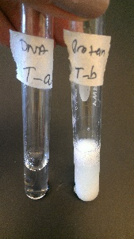Using a 10mL graduated cylinder and a disposable plastic transfer pipette, measure out and dispense three approximately ½ mL aliquots of egg white into the other 3 test tubes. Mark these tubes Protein T-b, Protein A-b, and Protein P-b (for Protein: Temperature test, Acid test, and Protein test).

**Temperature tests**:

1. Add 2mL (40 drops) of distilled water to tubes DNA T-a and Protein T-b. Mix gently with a small stir rod and place both tubes into a boiling water bath for 2 minutes.
2. Remove the test tubes from the bath, stir again with your small stir rod, and note the appearance of the tubes’ contents in your DAS.

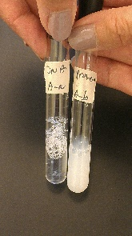

**Acid tests**:

1. Add 2mL (40 drops) of 1.0M HCl to tubes DNA A-a and Protein A-b. Stopper both tubes and shake for 2 minutes.
2. Carefully study the contents of the two test tubes and note their similarities and differences in your DAS.

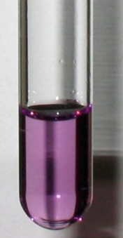**Protein tests**:

1. Add 2mL (40 drops) of distilled water and 5 drops of Biuret solution to tubes DNA P-a and Protein P-b. Using a new stopper for both tubes, stopper and shake them for 1 minute.
2. Carefully study the contents of the two test tubes and note their similarities and differences in your DAS.

**Checkout items (for both parts)**

|  |
| --- |
| Beakers: 100ml, 150ml, 250ml, 400ml, 800ml |
| Glass stirring rod |
| Gloves |
| Graduated cylinders, 10ml and 100mL |
| Hot plate |
| Plastic “ice bath” tub |
| Small stir rod, large stir rod with rubber policeman |
| Test tube rack and 6+ test tubes with stoppers |
| Thermometer |
| Timer |
| Wash bottle  Disposable plastic pipettes |

Adapted from:

Smith, J., *General, Organic, and Biological Chemistry*, 2nd ed.; McGraw Hill: NY, 2012.

Krieger, P.A., *A Visual Analogy Guide to Chemistry***;** Morton: Englewood (CO), 2012.

Valentin, D.; Pulido-Cordoba, L.; Chavez-Reyes, A. An Easy Way to Distinguish DNA from Protein: An Experiment for General Chemistry. *Journal of Chemical Education*. **2012**, *89*, 1333-1335.